 

Afghan Children Read

Online Textbooks Inventory Management System (OTIMS)

DISCLAIMER:

*This report is made possible by the support of the American people through the United States Agency for International Development (USAID). The content is the responsibility of Afghan Children Read and does not necessarily reflect the views of USAID or the United States government.*

Table of Contents

1 Introduction 1

2 Accessing OTIMS 1

3 Understanding the Dashboard 2

4 Sending Packages 3

5 Viewing Package Details 5

6 Receiving Packages 5

7 Distributing Books to Students 7

8 Sending Book Requests 8

9 Approving, Merging, and Forwarding Book Requests 9

10 Admin: Viewing Reports 11

11 Admin: Managing Users, Nodes, and Packages 11

12 Technical Support 11

# Introduction

The Online Textbooks Inventory Management System (OTIMS) is a web and mobile application developed for the Ministry of Education to digitize the current manual paper-based textbooks distribution process.

Ministry of Education (MoE) has exercised a tedious, paper-based, and manual textbook distribution process with complexities in tracking and monitoring of record keeping and distribution. This antiquated distribution system does not allow for tracking of textbooks and hence leaves loopholes for corruption, and it loses its effectiveness because timely and transparent recordkeeping and reporting is challenged by manual and separate recordkeeping at all levels i.e. central, provincial, district and school.

At the request of USAID-Afghanistan, Afghan Children Read (ACR) conducted a rapid assessment of the Ministry’s distribution system, and, in view of its findings, introduced an Online Textbook Inventory Management System (OTIMS) that is digitized, efficient, durable and cost-effective for replacing the old system. OTIMS provides an ICT solution to the Ministry’s old distribution system with clearly defined work flows of sending, receiving and recordkeeping of textbooks on all levels, starting from the MoE central and vendor level down to the provincial, district, school and student level, and vice versa. Furthermore, it provides a one-click report generation module for all the reporting and planning needs of the Ministry at all levels of textbooks distribution process. One of the many important reporting features is that of the lost or missing textbooks, which provides an accurate list of books that are missing at any level in the process. This, along with other features, helps assure transparency, accountability, and timely access to the books by the students.

The web instance of OTIMS for the Ministry of Education is currently hosted at <http://otims-af.com>. The interface of OTIMS on the web and mobile are identical, therefore, this guide can be used for both versions.

# Accessing OTIMS

To access OTIMS on the web, open your web browser, such as Chrome, Firefox, or Edge and navigate to  [http://otims-af.com.](%20http://otims-af.com.) You will be taken to the public home page of OTIMS from where you can login to access all the features of OTIMS.

If you are using the mobile version, simply open the OTIMS app on your mobile phone or tablet. The rest of the guide remains the same for both versions.

If you want to change the language of the OTIMS to Pashto or Dari, click the currently loaded language’s name (English) and choose your preferred language. Please remember that you can always change the language even after logging in.

To login, enter your username and password, and click the Login button. Your username and password should be provided to you during trainings by ACR or MoE.

The screenshot below shows the login screen where the username and password should be entered. You may click the lock icon in front of the Password field to reveal your password for making sure it is correct.

You can also download this user manual in English, Pashto, and Dari from the login screen by clicking the User Manual button.

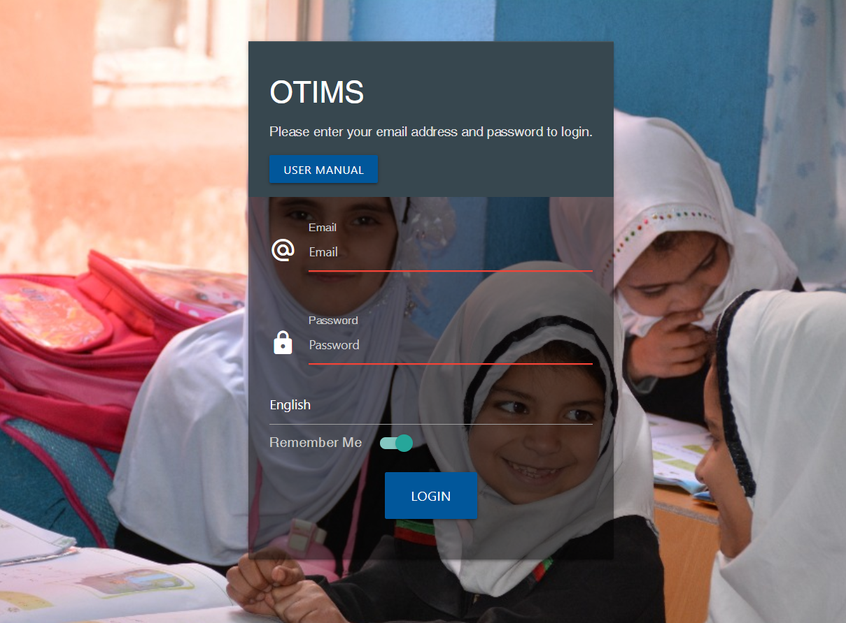

# Understanding the Dashboard

After logging in to the system, the dashboard will be loaded as shown in the screenshot below.

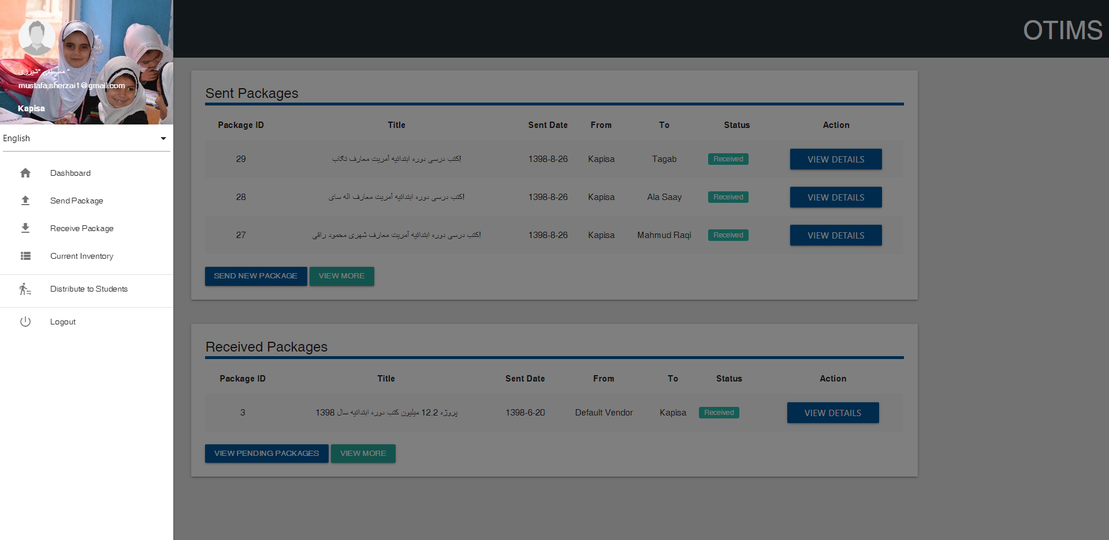

There are two main sections in this screen: a list of recently Sent Packages which lists the packages that have been sent by you, and a list of recently Received Packages or the packages that have been sent to you and need to be received. You will also find the main navigation menu on the left from where you can navigate to different parts of the application.

You can also change the language of the system anytime by expanding the menu and choosing the desired language from the dropdown list at the top.

# Sending Packages

If you have never sent a package before, the Sent Packages section should not contain any entries as opposed to what is shown in the screenshot where there are some entries.

To send a new package, please click the Send New Package button in the Sent Packages section from the Dashboard or click the navigation button on the top left and then click Send Package from the menu. Clicking this will load a form which contains three sections: Package Information, Titles & Quantities, and Send Package.

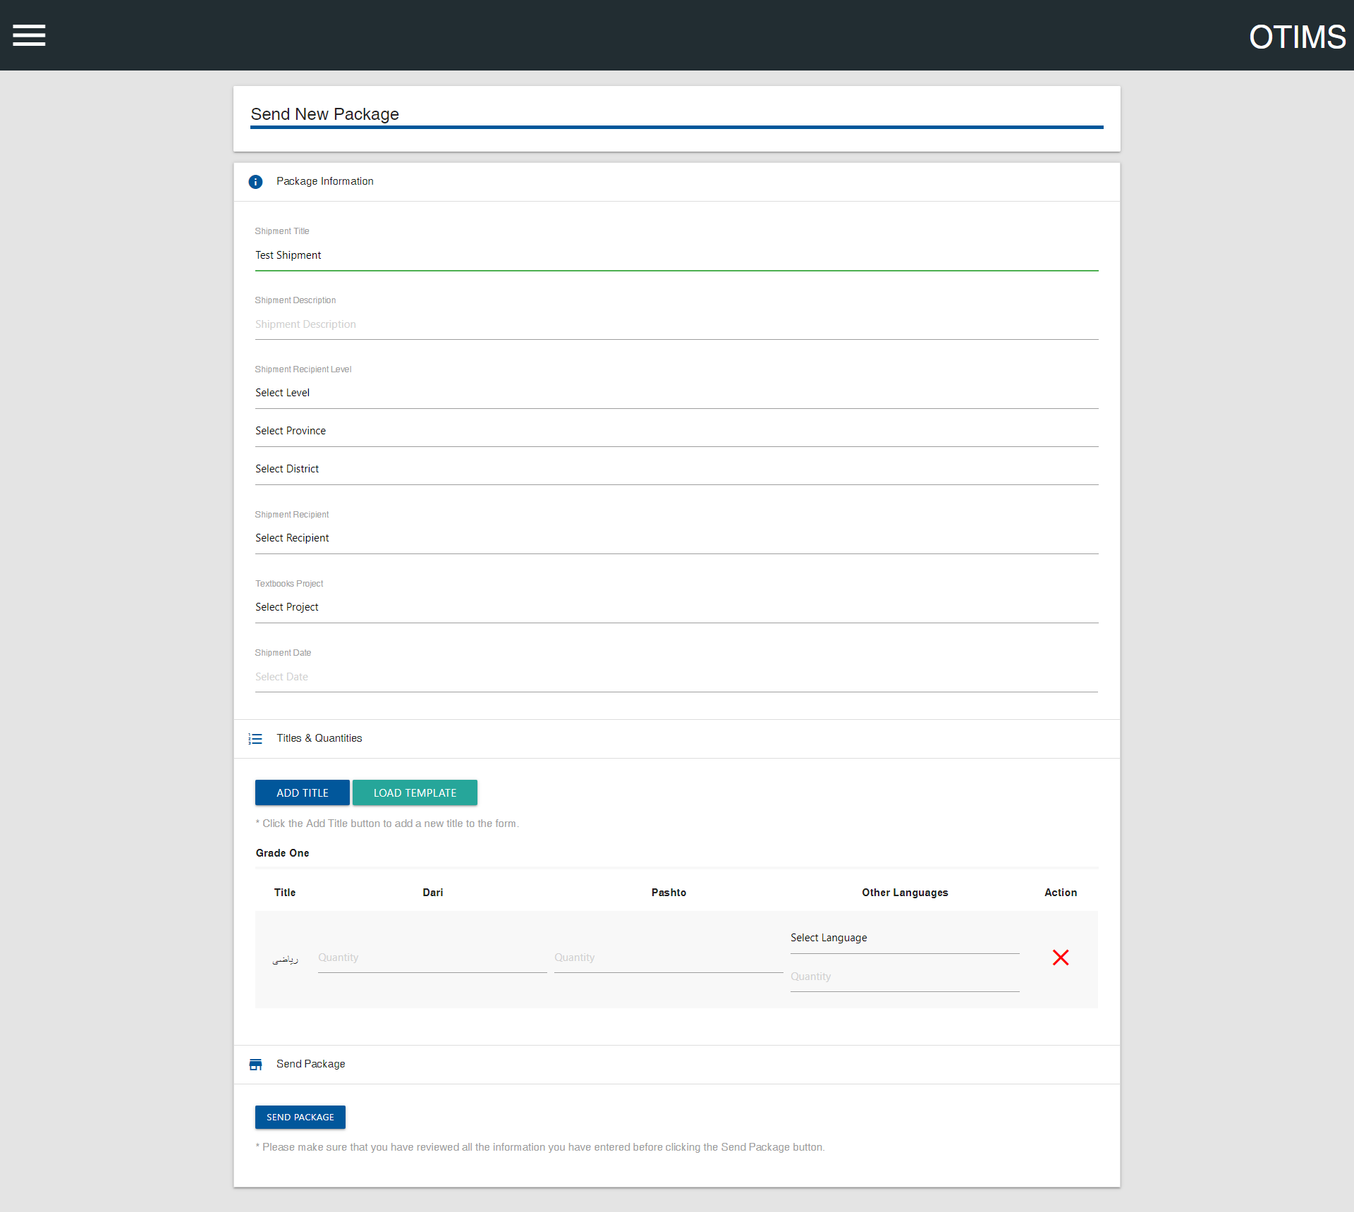

Start from the first section Package Information, and provide a Shipment Title, a Shipment Description, and select the Shipment Recipient Level from the list, this simply means, the destination where the books are being sent; for example, if you are sending this package of books to a specific district in a province, select “District”, and then select a Province from the drop down just below, and then select a District from the list of districts of the selected province.

You will also have to select the Shipment Date using the date picker. You can either select the date in Gregorian or Hijri, the system will automatically convert it to Hijri.

Once you are done with entering the information above, provide the information on textbooks that are being sent. This can be done through the second section Titles & Quantities. You will have to add each title that is being sent for each grade in the form.

For example, if you are sending a package of books which contains the following:

1. 100 Grade 1 Mathematics books in Pashto
2. 100 Grade 1 Mathematics books in Dari
3. 200 Grade 7 Chemistry books in Pashto
4. 150 Grade 7 Chemistry books in Dari
5. 100 Grade 8 Biology books in Pashto

You will add the titles and fill out the form as follows:

1. Click the Add Title button in the Titles & Quantities section, select Grade One from the list of grades, and select Mathematics from the list of titles of the selected grade, and then click the Add Title button. The title will be added to the form.
2. Repeat step 1 for all the titles i.e add Chemistry for Grade 7, and Biology for Grade 8 using the same procedure as described above.
3. Scroll down to find “Mathematics” in the titles list of Grade 1 and type 100 in the field just in front of the subject name in the Dari column and type 100 in the field just in front of the subject name in the Pashto column
4. Scroll down to find “Chemistry” in the titles list of Grade 7 and type 150 in the field just in front of the subject name in the Dari column and type 200 in the field just in front of the subject name in the Pashto column.
5. Scroll down to find “Biology” in the tiles list of Grade 8 and type 100 in the field just in front of the subject name in the Pashto column. Since there are no books being sent in Dari, simply leave that field empty.
6. Click the “Send Package” button in the last section to send the package. If you have filled the form correctly, a confirmation dialog will appear showing all the details of the package you are sending.
7. Carefully read the details in the dialog and make sure everything is correct before pressing the Send Package button again. Otherwise, click Cancel and make the necessary changes.

If the package gets sent, you will receive a confirmation message saying the same. Otherwise, a list of errors will be displayed at the top which can guide you on making the necessary changes for the package to get sent.

If the inventory does not have the same or a greater number of books available for a specific title, you will get an error saying that the available balance is lesser than what is being sent. Otherwise, the package will get sent and the status of the package will be set to “Pending”.

Once the recipient receives the package on the other end and fills the receiving form, the status will automatically be changed to “Received”.

# Viewing Package Details

In the Sent Packages section, you can see a list of the packages that you have sent along with their status which will either be “Pending” or “Received”.

Similarly, in the Received Packages section, you can see a list of the packages that have been sent to you along with their status which will either be “Pending” or “Received”.

If you want to see the details of a specific package, click the View Detail button in front of it which will load a dialog with all the information listed as shown in the screenshot.

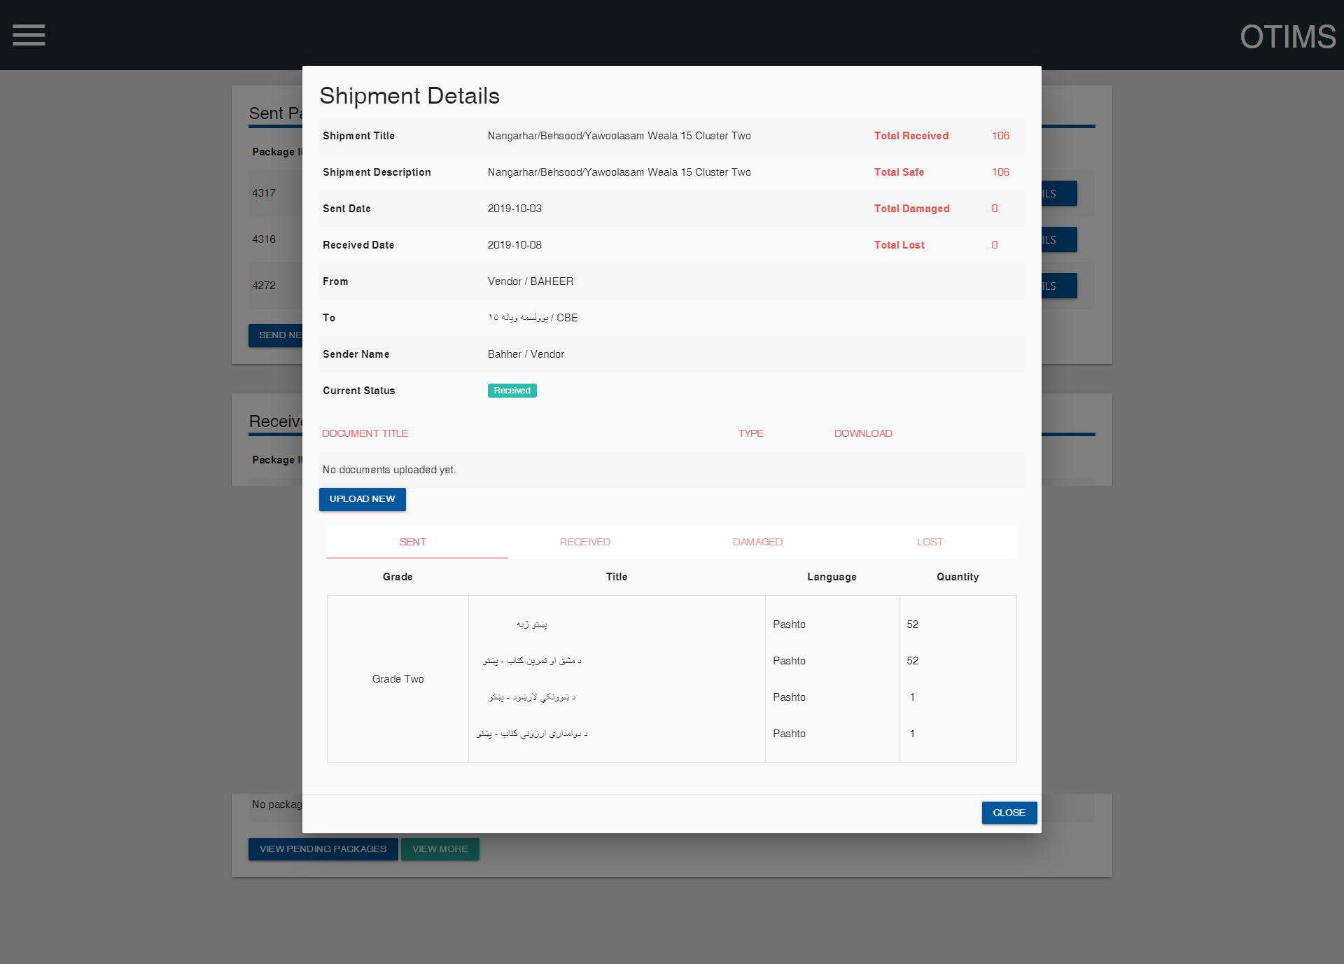

If the status of the package is “Received”, you will be able to see a comparison of what was sent and what was received, thereby, giving you a clear picture of missing and damaged books, if any.

From this screen, you can also view and upload any supporting scanned documents for this package by clicking the Upload New button in the documents section

# Receiving Packages

In the Received Packages section, you can see a list of the packages that have been sent to you along with their status which will either be “Pending” or “Received”.

“Pending” here means that the package has been sent to you, but you need to receive it by filling the receiving form, and packages with the status of “Received” are the packages that you have previously received by filling the receiving form for it.

To view the details of, or to receive a package, click the View Detail button in front of it. A dialog box will appear which contains all the information about the package including what has been sent to you with exact numbers for all the sent books.

Now, to receive a package, you will have to click the Receive button in the dialog and fill out the form with exact numbers for whatever books you have received. The relevant titles will already be added to the receiving form. You can either manually enter the quantities for each title in each language or click the “Fill with Sent Quantities” button to automatically fill the form with the quantities as has been sent and then make the necessary changes if any.

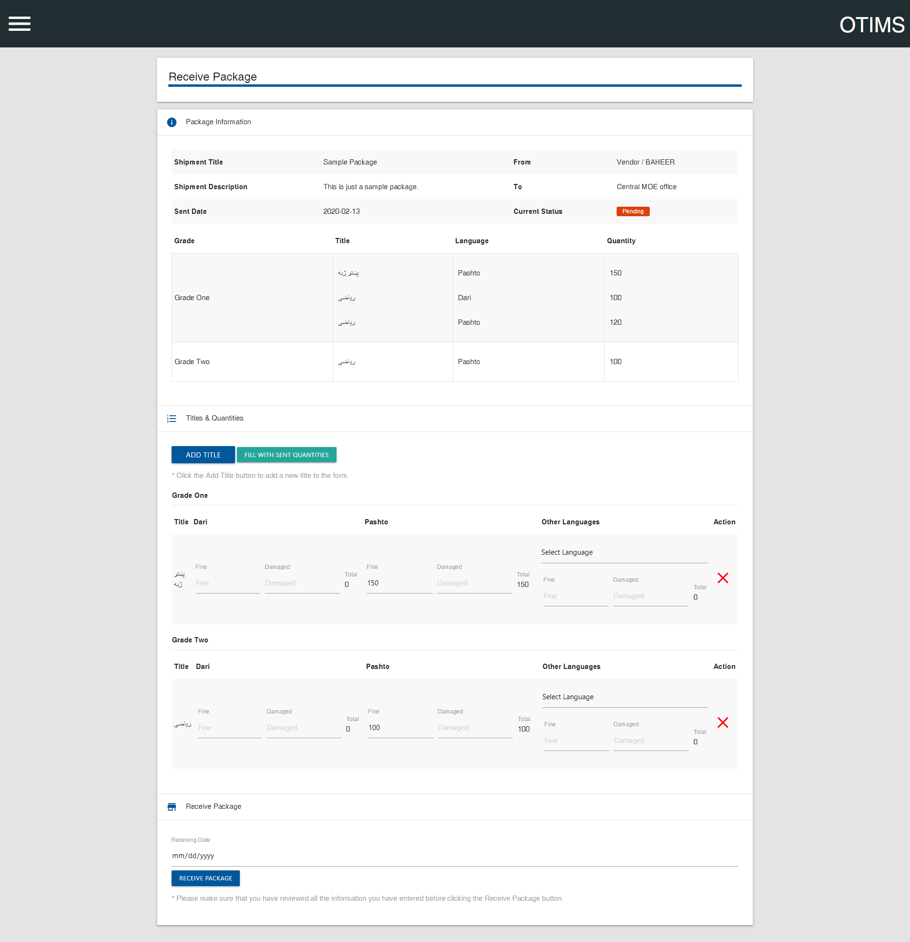

As shown in the screenshot above, you will be shown full details of what books in what quantities has been sent to you. To complete receiving a package, you will have to fill out the receiving form with exact quantities of whatever books you have received.

Once that is done, simply click “Receive Package” button in the bottom of the form to complete the receiving process. If the package gets received, you will receive a confirmation message saying the same. Otherwise, a list of errors will be displayed at the top which can guide you on making the necessary changes for the package to be received.

From the previous screen, you can also upload and attach any supporting scanned documents for this package by clicking the Upload New button in the documents section

# Distributing Books to Students

The Send Package and Receive Package sections allow you to send and receive packages to and from Vendor, Center, Province, District, and School. However, the actual data entry of books distributed to students happens in Distribute to Students section.

Ideally, a school level OTIMS account should do the data entry for the number of books distributed to students and received back from the students (at the end of the year, for example), however since that may not be possible in most cases due to limited access to digital systems in schools, a district level account can also do the same data entry for the schools which belong to the specific district.

To access this section, click the menu icon on the top left and then click “Distribute to Students”. This will load a screen where you can select the school for which you want to do the data entry in case of a district level account logged in. If it is a school level account logged in, you will only be able to select your own school from the list. Once you have selected the school, the following sections will be displayed as shown in the screenshot.

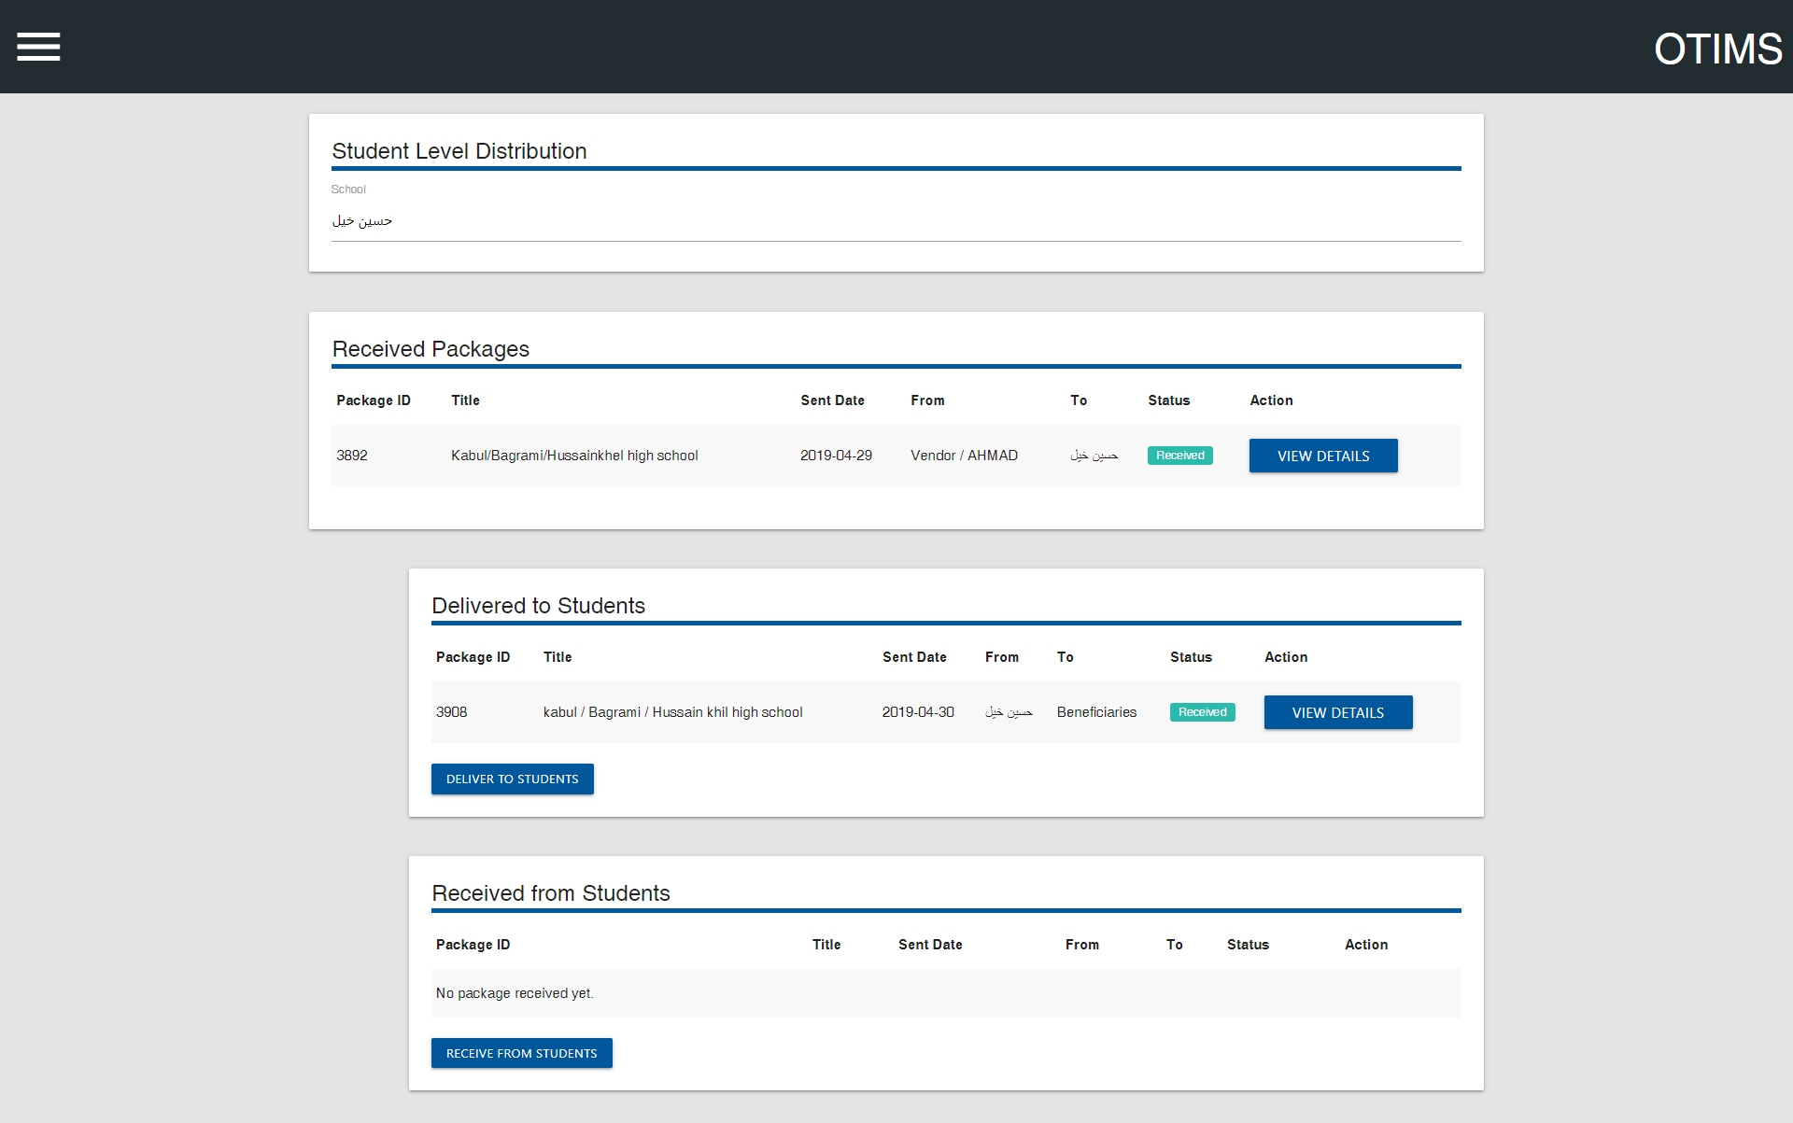

The sections of interest here are the Delivered to Students and Received from Students. As the names suggest, Delivered to Students shows the books that have been distributed to students in the form of packages, and Received from Students shows the books that have been received back from students, also in the form of packages. Receiving books back from students usually happens at the end of the academic year and the books are stored in the inventory for use in the next academic year.

To distribute books to students, simply click the Deliver to Students button, or to receive books back from students, simply click the Receive from Students button. Both sections are identical to the Send Package section and can be used the same way as described in section 4. Sending Packages.

# Sending Book Requests

The requisition module was built into OTIMS to enable nodes to request books from their parent nodes. For example, if a school needs some books, the school node can use the requisition module to request books from the district under which the school falls. The same is true from district to province and from province to center.

The requisition module digitizes the whole book requisition process and enables users to upload scanned documents to each request.

To access the requisition module, click the navigation button on the top left and then click Request Books. A screen which looks very similar to the home page will be loaded as shown in the screenshot below.

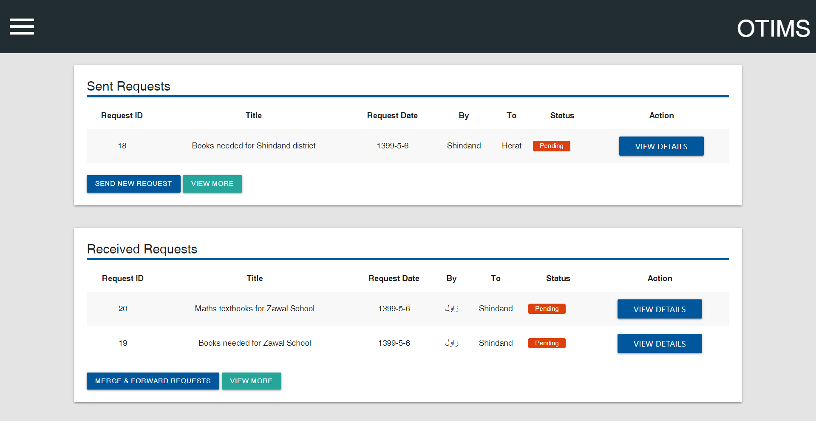

The interface of the requisition module is very similar to the interface of sending and receiving packages, and it makes it easier to use.

Here you can see the list of requests that you have sent, and the list of requests that you have received from child nodes. You can also view the details of each request by clicking the View Details button in front of a specific request.

To send a new request, please click the Send New Request button in the Sent Requests section. Clicking this will load a form which contains three sections: General Information, Titles & Quantities, and Send Request.

The form looks and works the same as the Send Package form. You may refer to the Sending Packages section of this manual for more details on using it.

Once you are done with filling the form, simply click the Request Books button in the last section which will load a dialog displaying all the information you have entered for your confirmation.

Carefully read the details in the dialog and make sure everything is correct before pressing the Request Books button again. Otherwise, click Cancel and make the necessary changes.

If the request gets sent, you will receive a confirmation message saying the same. Otherwise, a list of errors will be displayed at the top which can guide you on making the necessary changes for the request to get sent.

# Approving, Merging, and Forwarding Book Requests

If you have received requests from your child nodes, they will be displayed in the Received Requests section. For example, if you are a district and have received book requests from schools, all of those requests will be displayed in the Received Requests section and you can approve, merge, and forward the requests from here.

To approve a request, click the View Details button in front of the request, and then click the Approve button.

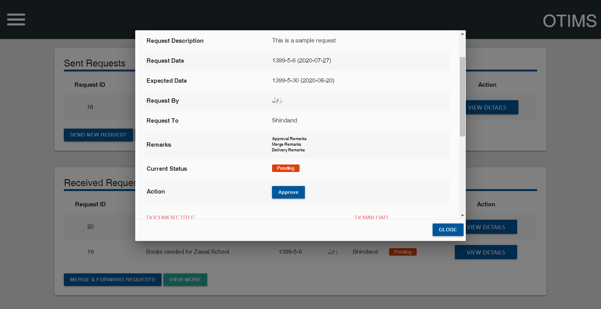

Clicking the Approve button will load a small dialog box where you can write your remarks for approval or you may leave it empty. Once that is done, simply click the Approve Request button to approve the request.

Once you have approved the request, you may want to send it to your parent node (let’s suppose, your province) for further processing as per the textbooks request process. You can either forward a single request or merge many requests into one and forward it.

Here, we will merge two requests into one and forward it to the province. To do so, please click View Details button in front of one of the approved received requests and then click the Forward button which will load a form which looks like the Send Request form as shown in the screenshot below.

This form also contains three sections: General Information, Titles & Quantities, and Send Request. It works the same as the Send Request form, but it has some more functionalities built into it.

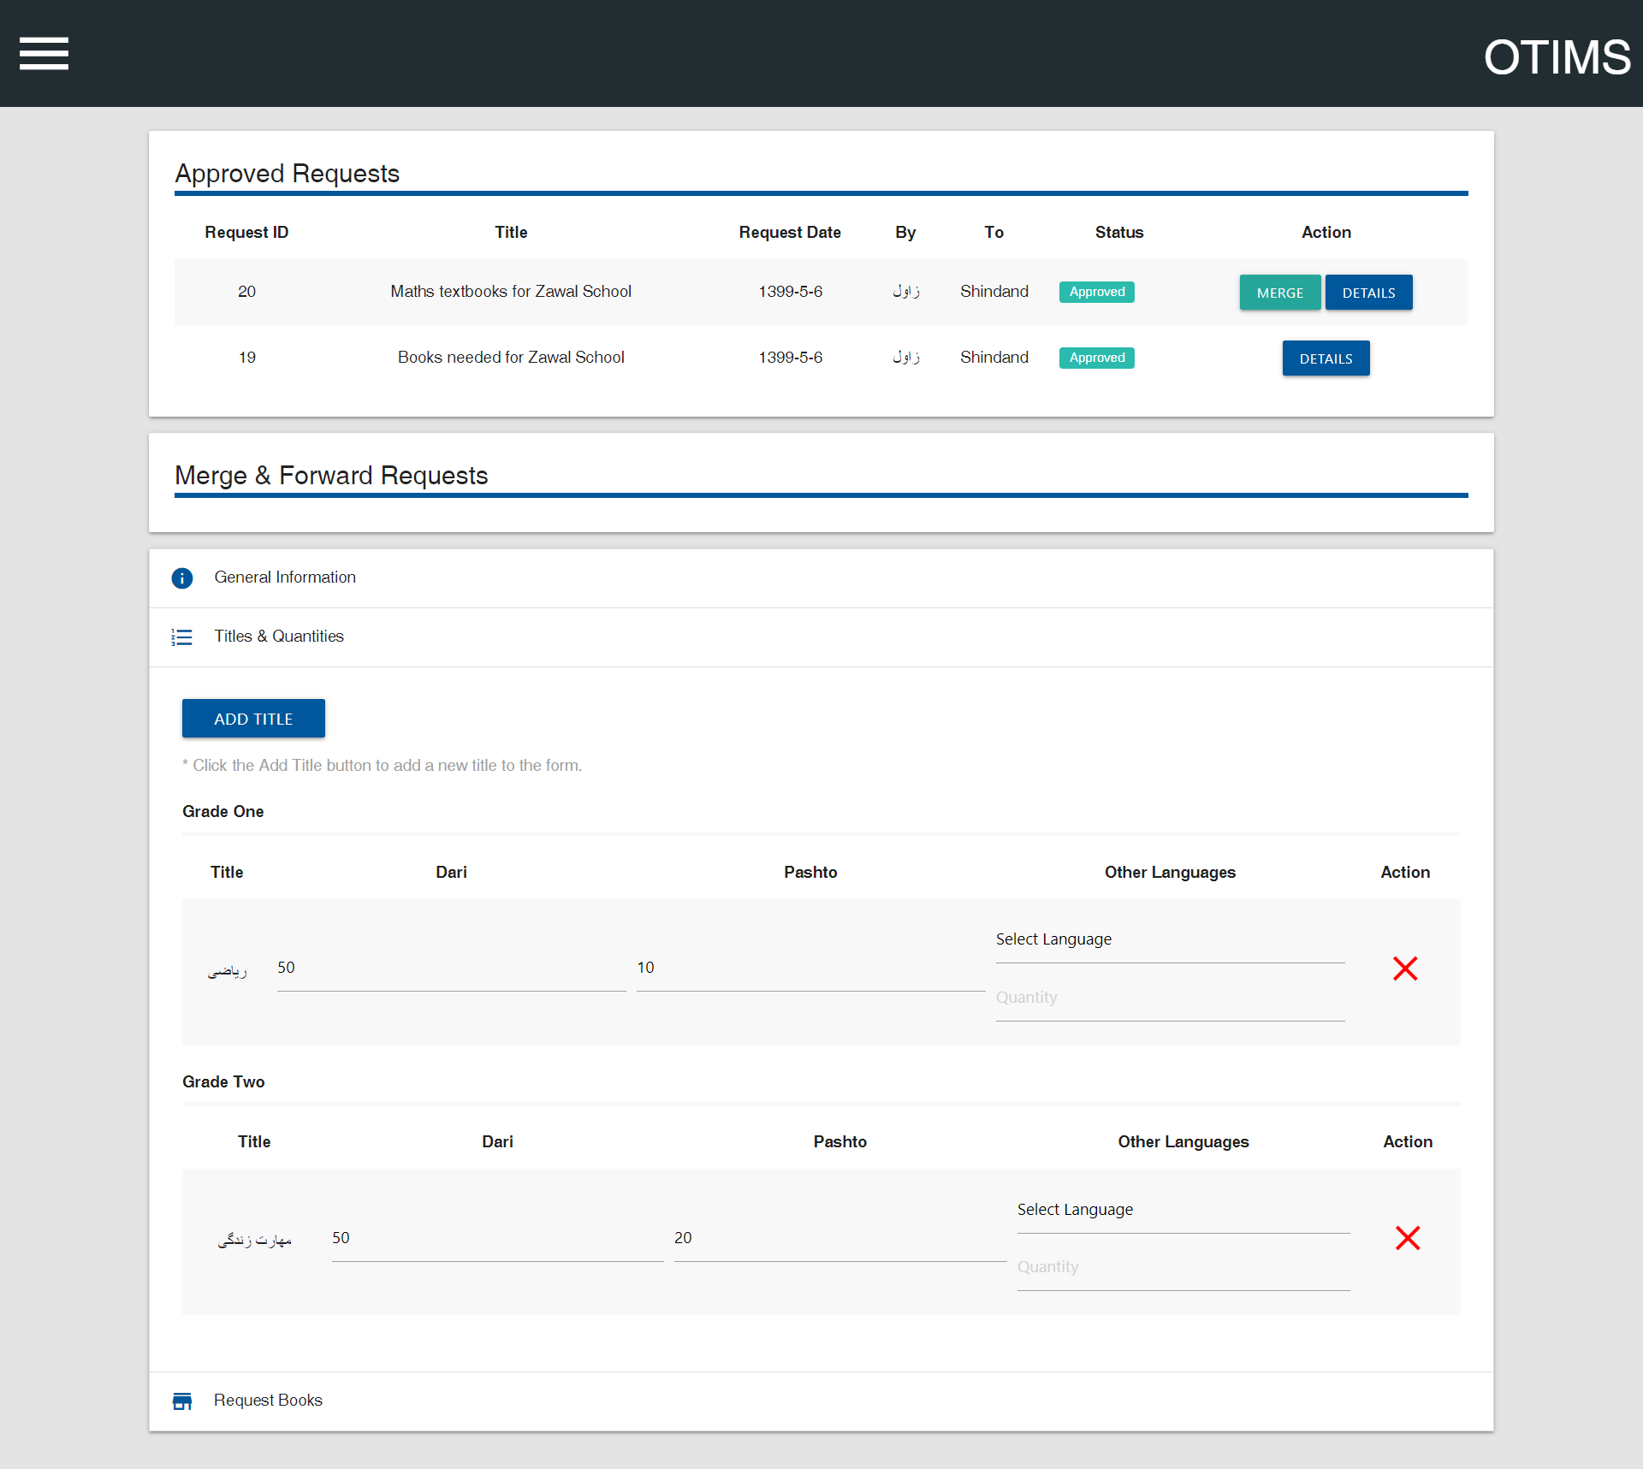

The first section above the main form is the list of Approved Requests which have not yet been merged with other requests or forwarded. Please note that you can only merge or forward requests which you have already approved. Pending requests will not be displayed here and will not have the Forward button.

You may fill the General Information section of the form with the required information and proceed to the Titles & Quantities section. This section of the form will already be filled with the information of the request you have clicked the Forward button for. You can also make changes to the titles and quantities if you want.

If you want to forward this single request as it is, you may click the Request Books button in the last section of the form, and it will be sent after your confirmation.

However, if you want to merge more requests with it, please click the Merge button in front of the request that you want to merge from the Approved Requests section on the top.

The Titles & Quantities section will automatically add the required subjects from the request and calculate the correct quantities for all the requests that get merged.

You can merge as many requests as you want by following the same procedure. Although the system automatically adds the required subjects and calculates the quantities for all the requests, you have the chance to add or remove subjects or change the quantities as you want.

Once you are done merging the requests, you may click the Request Books button in the last section of the form, and it will be sent after your confirmation.

Please note that requests that get merged will reflect the same in the Current Status column and the Description column will have the Request ID of the request where it was merged and forwarded with.

Furthermore, the same process may be repeated at the province level to merge the requests of many districts into one and forward it to the center for further processing.

# Admin: Viewing Reports

OTIMS has a good built-in reporting module, which can generate reports of textbooks distribution on all the different levels including province-wise, district-wise, and school-wise reports.

You can only access the Distribution Reports section if you are an admin, otherwise, the Distribution Reports entry will not be displayed in the navigation menu.

# Admin: Managing Users, Nodes, and Packages

If you are an admin, you will be able to see some more entries in the navigation menu namely: Manage Users, Manage Nodes, and Manage Packages.

As evident from the names, you can use the Manage Users section to create or delete user accounts for using OTIMS. Similarly, you can use Manage Nodes and Manage Packages to create, edit, or delete nodes and packages.

For example, to add a new school to a district, you will use the Manage Nodes section. Similarly, if you want to edit or delete a package that has been mistakenly sent by someone, you will use the Manage Packages section.

The details and step by step guides for the admin sections are out of the scope of this user manual.

# Technical Support

If you face any problems using the application, please get in touch with the ICT Unit of the ACR Project or whoever has been designated and introduced for providing technical support.

To contact the ICT Unit of ACR, please send an email to Zabeehullah Khan at [zabeehullahk@readafghanistan.com](mailto:zabeehullahk@readafghanistan.com) or M. Mansoor Zamani at [mohammadmz@readafghanistan.com](mailto:mohammadmz@readafghanistan.com) with your query.